Frequently asked questions
Questions and replies related to the issues in CDR and reporting tools
This note provides information on known issues (errors) on CDR and in reporting tools (CDR Automatic QA, validation inbuilt in the reporting tool, accessibility of range tool)

General issues on CDR

Reason for change (main reason for change) error message
I get the following error message but I reported only 1 reason for change (without filling in the main reason). It is triggering one of the following errors, and I do not understand why? Incoherent information in this section. Only one main reason is expected and should be part of the reported reasons (Errors S090, S148, S236, S241, H036, H087, H184, H188).
- This is a bug from the reporting tool that occurs when the user selects more than one reason (e.g. “genuine” and “method”), then selects a main reason (e.g. “genuine”), and then unticks this reason (e.g. “genuine”). In this case, the main reason field remains empty in the tool, but the value is still stored in the database (e.g. “genuine”), triggering the error mentioned above. We recommend systematically filling in the field ‘main reason’ even if only one reason has been ticked.

Conservation measures (QA returns mandatory information missing for non-Annex II species)
Errors on mandatory information missing for Conservation measures triggered for non-annex II species (errors H134 to H151 and S187 to S204)
- The QA is built in a way that errors are triggered if data are reported (even partially) for non-annex II species. These errors should be ignored, as they will not be taken into account in the analyses (as only annex II species will be considered).

Impossible to use decimals for surface area of sites in general report
[General report] The validation rules for error-codes G036 & G041 state that for surface area of marine sites decimal places are not permitted, unlike for the other surface area data.
- Please ignore the error messages (G036 and G041) and report the requested areas using decimals. If this issue is not fixed in the meantime, we will remove these errors manually.

Use of measures/ pressures categories in the reported list of conservation measures / pressures and threats
[Habitats and Species reports] BLOCKER is triggered for reported codes for threats, pressures and/or conservation measures. The error message indicates the code is invalid, but the reporting tool allows selecting this code. This is the case of codes for categories of pressures and measures (e.g. A Agriculture or CA Measures related to agriculture) (Error codes H148, H115, S170, and S201).
The Explanatory notes and guidelines requests the list of the conservation measures taken to be reported under fields 8.5 or 9.5 ‘List of main conservation measures’. In the List of conservation measures available on the reference portals the conservation measures are classified into several measure categories (e.g. CA Measures related to agriculture).
Using measure categories with 2 digit code (e.g. CA Measures related to agriculture) in 8.5 or 9.5 ‘List of main conservation measures’ is not permitted, only measures with 4 digit code (e.g. ‘CA01’) can be used. The measure categories are not included in the ‘measures’ data dictionary (http://dd.eionet.europa.eu/vocabulary/art17_2018/measures/view) and the CDR validation will trigger blockers if these are used in the reported data (it won’t be possible to submit the national report via CDR).
The codelist of conservation measures mirrors the codelist of pressures and threats and the conservation measures are principally understood as an action to mitigate the impact of past and present pressures. Only conservation measures on contrary to measure categories can be fully used in later analyses, particularly to analyse the relation between the reported pressures and measure taken.

The same guidance applies to list of pressures and threats in ‘Characterisation of pressures/threats: a) Pressure/threat’ (8.1a or 7.1a), where the guidelines requests that ‘pressures/threats codes at the second level of the hierarchical list’ should be used to provide information in field.

Issue related to the Art17 reporting tool

Impossible to fill in the section 3 on “Hunting bags”
The tool does not allow me to fill in the section 3 on “Hunting bags” for species
- Unfortunatelly, this is related to a language settings issue. We recommend you to follow the step by step guidance (see annex I) to make this section editable.

Problem filling in favourable reference population

- Validation of tab 6 (species) is not successful if I select the values of field 6.15b or 6.15c. The application also requires input in field 6.15a, which is contrary to the guidelines.
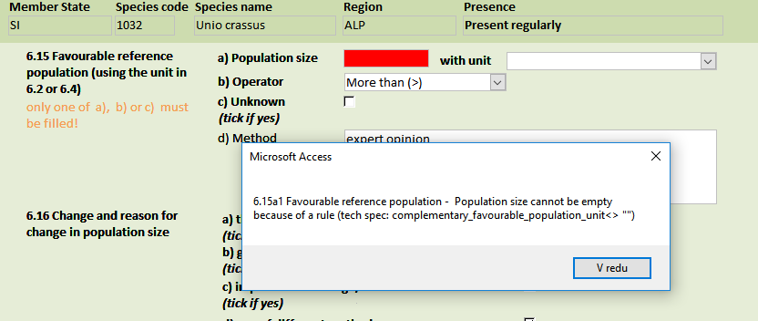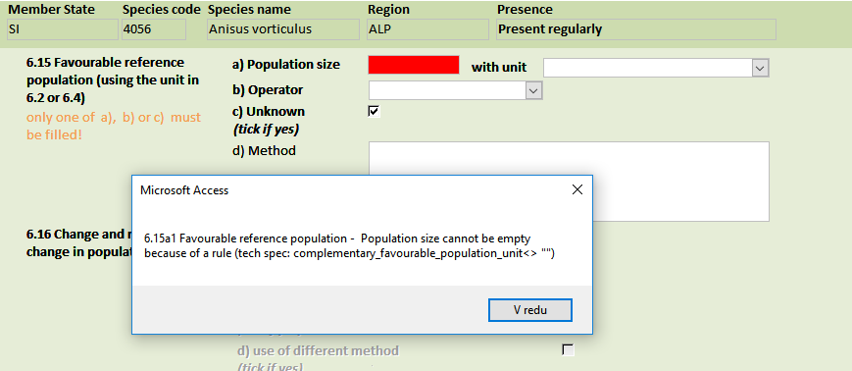
- The validation (validate buttons) of this section does not function properly. Please ignore the error message(s) wrongly triggered. We recommend you to press the button “Run QA” to get the final overview of any issues in your data (‘Run QA’ provides a correct feedback for this section)

Validation issues for ‘conclusion of parameter Future prospects’
In some cases, the validation of the report is not successful and returns the error below:
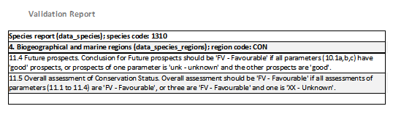
The actual values in tabs 10 and 11 are visible below. The information is fillied in according the explanatory notes and guidelines.

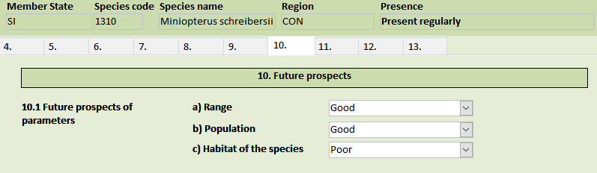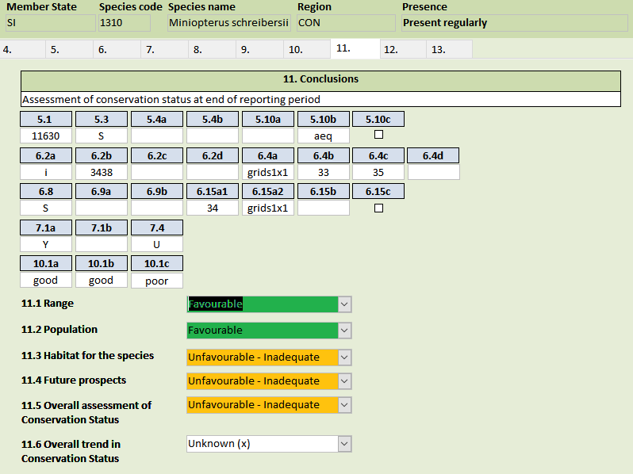
- The validation (validate buttons) of this section does not function properly. Please ignore the error message(s) wrongly triggered. We recommend you to press the button “Run QA” to get the final overview of any issues in your data (‘Run QA’ provides a correct feedback for this section)

Response to the measures when no measures are taken

When for 8.1 Status of measures option “a - Measures identified, but none yet taken” or “c - Measures needed but cannot be identified” are chosen for habitat report it is impossible to know the response time since nothing have been done or measures not identified Validate QA in the tool is triggering an error, if 8.1a is ‘yes’, and 8.1b is different than ‘taken’ (meaning different than measures identified and taken) and 8.4 empty. Similarly on contrary for other fields 8.2 and 8.3 the field 8.4 is not greyed oput (remains active making an impression that answer to 8.4 is requested)
- The validation (validate buttons) of this section does not function properly. Please ignore the error message(s) wrongly triggered. We recommend you to press the button “Run QA” to get the final overview of any issues in your data (‘Run QA’ provides a correct feedback for this section).
- Although field 8.4 remains active the answer is not requested unless answer to 8.1 is ‘measures identified and taken’

Issue related to the range tool/access to CDR

Problems with access to the range tool
I haven't access to the range tool and CDR for a few days. I use the same username (xxxx) and password (yyyy) as I did before, but the application always tells me that I'm using the wrong password.
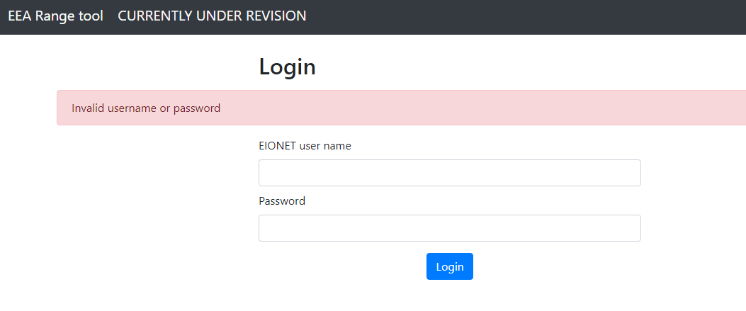
- If it is not possible to log into your range tool account, this can be related to expiry of your password. Please try to login into eionet homepage (https://www.eionet.europa.eu/) and if you cannot login, follow the instructions here https://www.eionet.europa.eu/news/time_span_of_the_eionet_passwords.

I access the range tool and click ‘choose file’ to upload my data, however the folder is empty when I navigate to it and therefore I cannot upload data.
- The range tool only recognises zipped folders either with a merged shape file or several shapefiles containing the species or habitats data.

I upload a zipped file of species distribution and run the tool. Eventually I see that the range cannot be calculated. What is the cause of this?

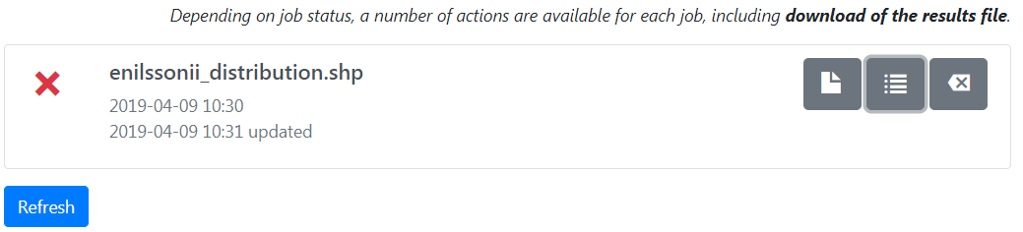
- There are a few things to check:
-Check the original shp and ensure the data can be displayed in your GIS software i.e. distribution falls within the Member State, within the appropriate biogeographical regions.
-Check that the parameters have been entered appropriately e.g. that a species has not been entered for a habitat etc.
-There is an option on the range tool to check the FME job log which might give some idea as to why the calculation has failed.
-If unresolved, report the issue, with any screen shots and zipped test data, to nature.helpdesk@eionet.com.
  - The CSV files do not have a calculated range for some species or habitat codes.
- This is more than likely because a species or habitat code has been included in the distribution shp but has not been updated in the reference checklist that the range tool calls on to create the range boundaries. Check firstly whether this species/habitat belongs in your shp file, if yes then ensure that the ETC is aware that this species/habitat needs to be added to the checklist.
- It is not necessary to use the range tool to calculate a range. This can be done by some other means, guidance on ranges and the data used for them are provided on the reference portal (https://circabc.europa.eu/d/a/workspace/SpacesStore/5b74d59f-c82e-424a-8070-bf190fdcf990/Reporting%20guidelines%20Article%2017%20final%20May%202017.docx and http://cdr.eionet.europa.eu/help/habitats_art17/Reporting2019/Reporting_tools_guidelines_Draft.pdf).

Annex I: Language setting issue
First, you might do a safety copy of your database.
Then go to file->options->language and select English in "Choose editing languages", then set English as priority 1 in "Choose display and help languages" as indicated in the image here below.
Press “OK”. Then you need to close Access and re start the reporting tool.
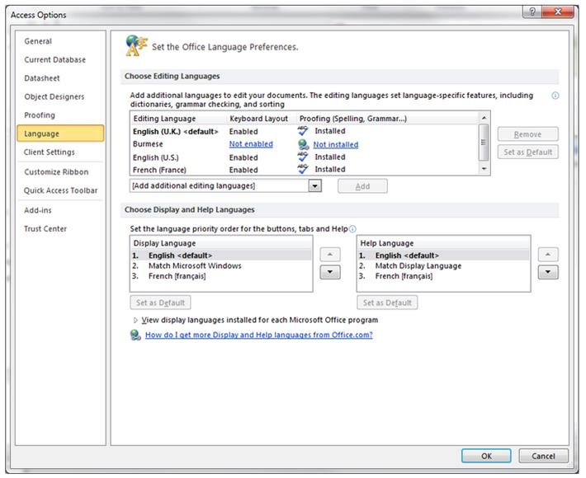
Please let us know if these explanations help to fix the issue.

